Creating a Public Amazon S3 Bucket

Objective- To create and configure an Amazon S3 bucket that allows public read access to hosted content, enabling any user on the internet to access stored objects.
Step1 - Sign in to AWS Console
- Go to https://aws.amazon.com and sign in to your AWS Management Console.
- Click on the S3 service .From the S3 dashboard click on “Create Bucket”.

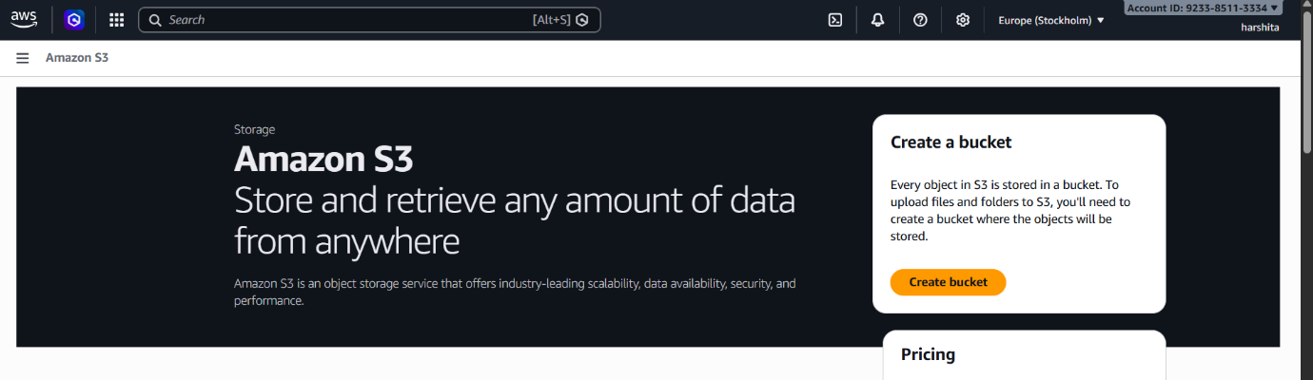
Step2 - Configure Bucket Name
- On the S3 dashboard, click on "Create Bucket". Enter a unique Bucket Name (must be globally unique).
- 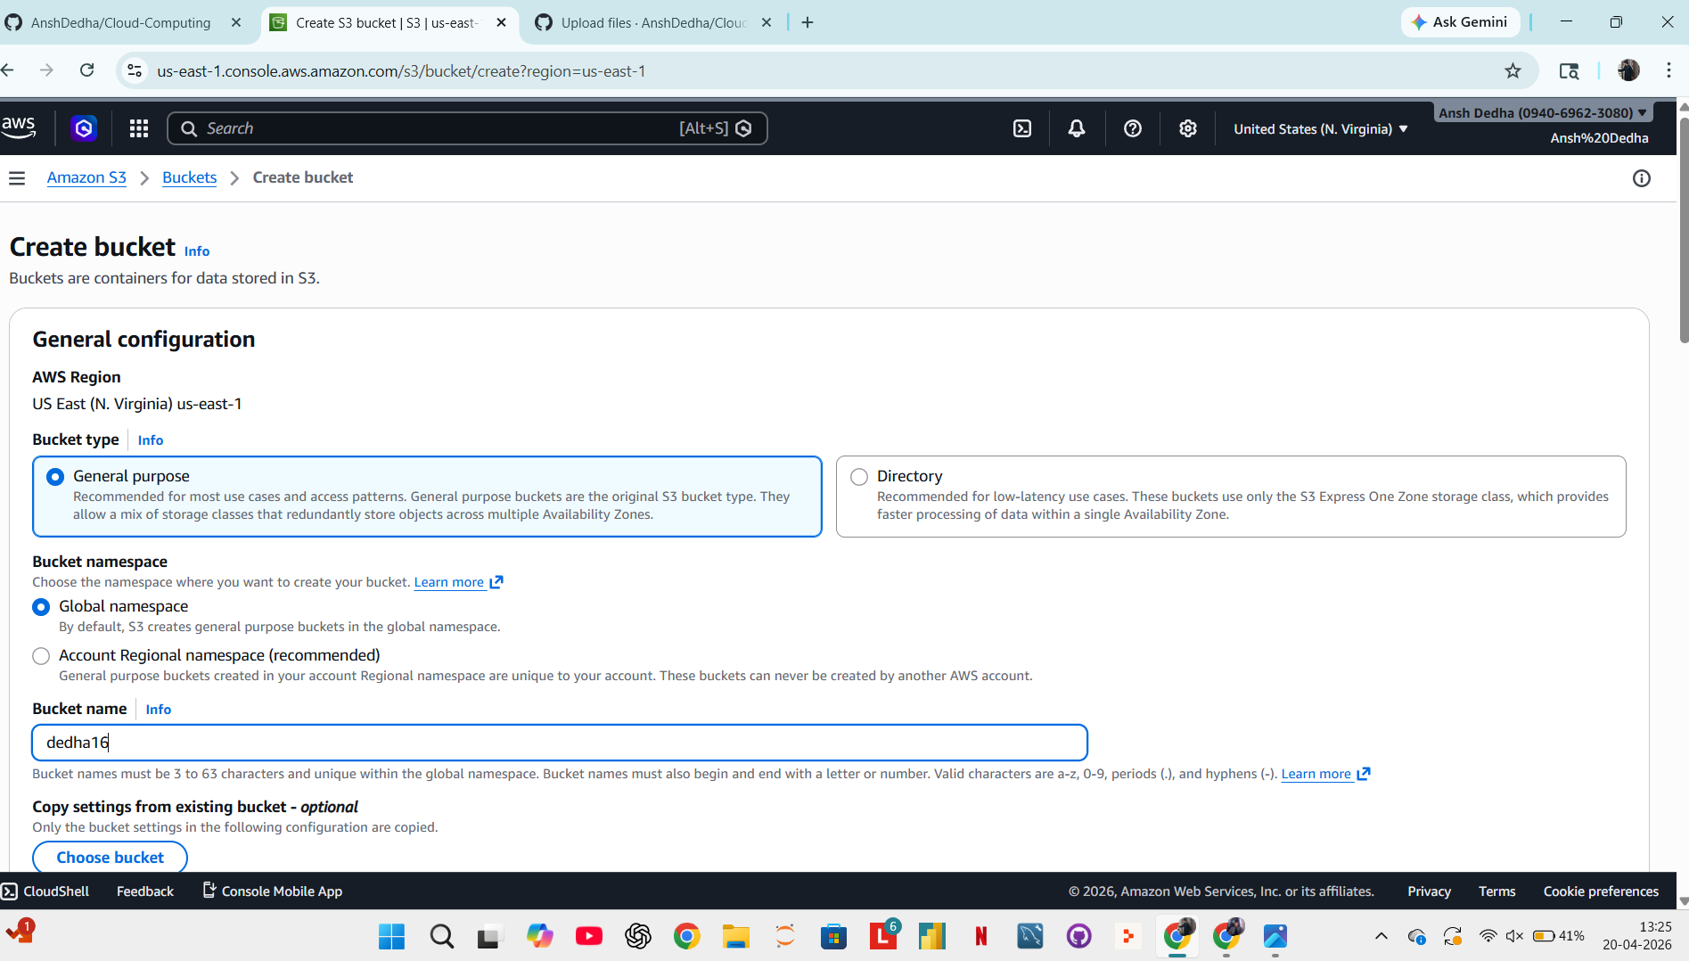

Step3 - Configure Object Ownership
- Under Object Ownership, select "ACLs enabled".
- Choose "Object Writer" so the uploading account owns the object.
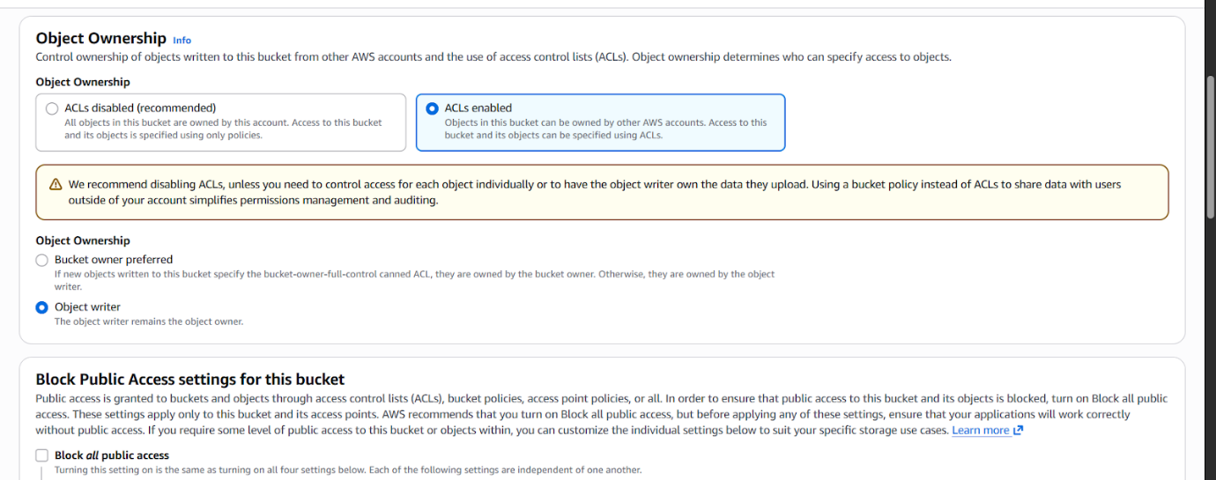

Step 4 - Disable Block Public Access
- Under Block Public Access settings, uncheck the option "Block all public access".
- A warning prompt will appear — type "confirm" to acknowledge that the bucket will be publicly accessible.
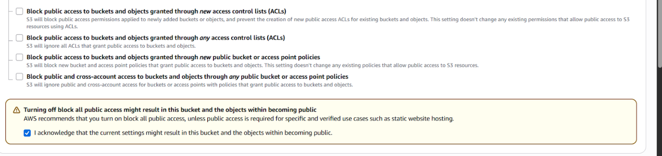
Step 5 — Leave Other Settings as Default than scrool down and click on “Create Bucket”.
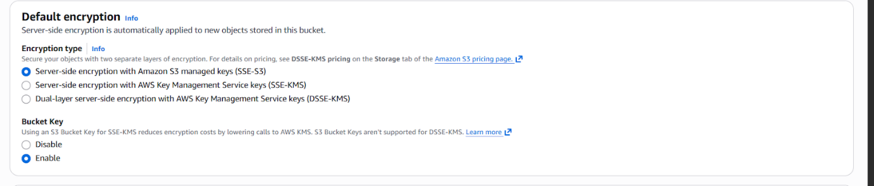
Step-6 Add an Object to the Bucket.
- Click on “Upload”. Click “Add Files” and select the file you want from your device. Leave permission as default(private).
- Click “Upload” to add the object to the bucket.
- 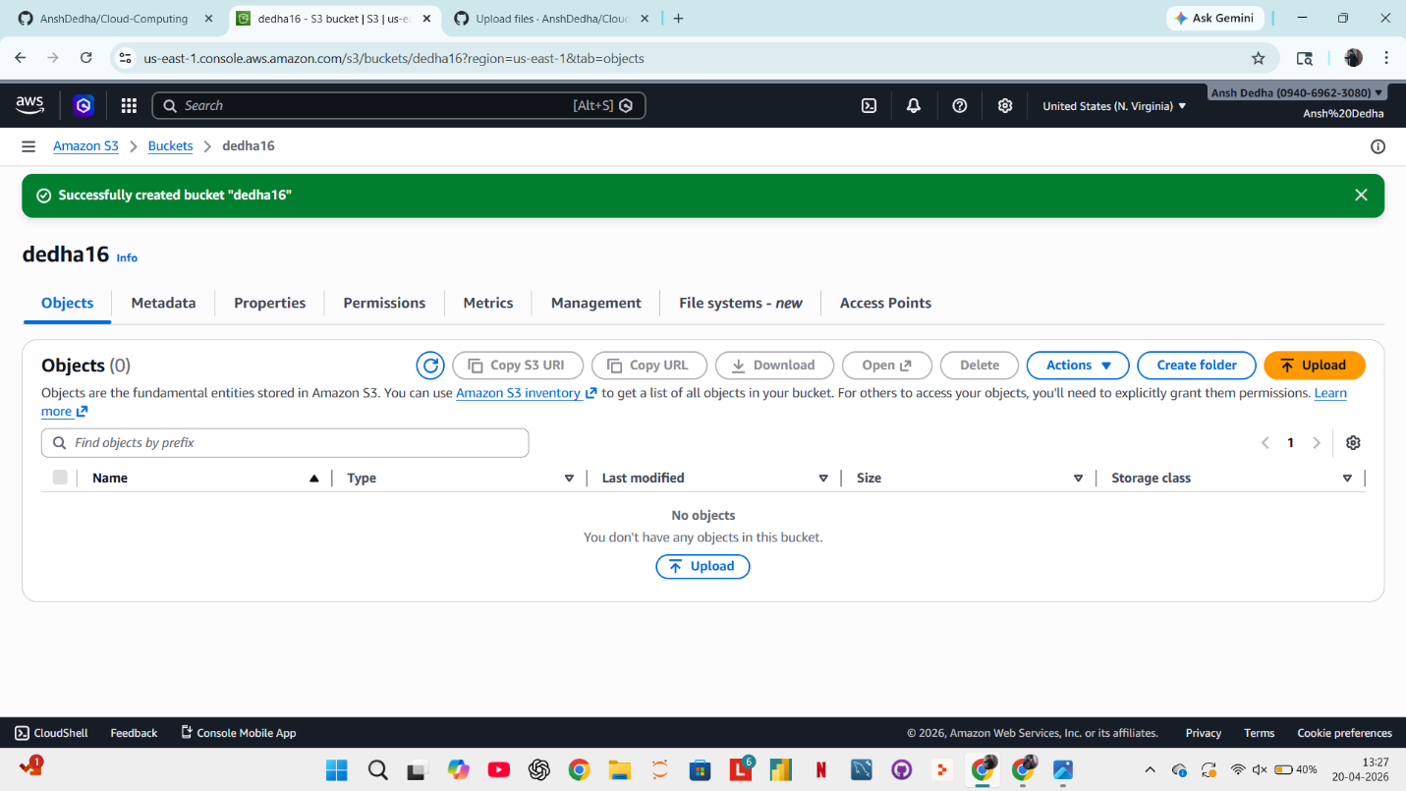

Step-7 Making the object public
- Go to your bucket and click on the uploaded object to open its details.
- Click on the "Permissions" tab of the object.
- Scroll down to the Access Control List (ACL) section and click "Edit".
- Under Grantee — Everyone (public access), check the box for "Read" under the Objects column.
Click "Save changes”.
